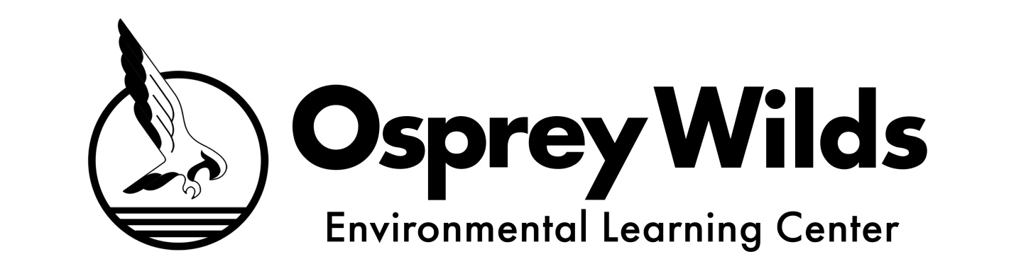

Request for New Charter School Applications

Background
The Osprey Wilds Environmental Learning Center (Osprey Wilds) authorizes 39 charter schools throughout Minnesota. Our vision is to authorize a portfolio of high performing charter schools that instill a connection and commitment to the environment in their school communities, while working towards a healthy planet where all people live in balance with the Earth. Our authorizing mission is to ensure quality academic and environmental literacy outcomes for Minnesota students through effective charter school authorizing.

New School Priorities
Osprey Wilds aims to expand learning opportunities for students in Minnesota; therefore, we seek high quality new school applications from individuals and groups who have the skill, capacity, and vision to initiate and sustain high quality, innovative public charter schools. Successful applications will present plans to provide all students, including those with special needs and English learners, with a quality education that develops the whole child, ensure efficient use of public resources, and develop the environmental literacy of children and youth. A successful application will also describe how the proposed school will meet the primary purpose of Minnesota’s charter school law, which is to improve all pupil learning and all student achievement.

Osprey Wilds is specifically interested in applications in the following four categories:
- Models that include environmental education as a central component of the educational program, especially those serving students in low income communities, rural communities, indigenous communities, and / or communities of color.
- School planning teams and start-up boards of directors that include youth.
- Schools that used personalized or individualized learning as a central component of the educational approach, ensuring that students’ education is relevant to how they learn, who they are and what they aspire to do in the future.
- Schools that intentionally bring together students and founding teams of different socioeconomic, ethnic, and / or cultural backgrounds.

In addition, Osprey Wilds seeks charter school applications that prioritize the following additional statutory purposes as outlined in MN §124E.01:
- Encourage the use of different and innovative teaching methods; and / or
- Measure learning outcomes and create different and innovative forms of measuring outcomes.

Osprey Wilds New Charter School Application Process
- Developers should become familiar with Minnesota statutes Chapter 124E which govern charter school formation and operation. Visit Osprey Wilds’ website to learn about our authorizing activities and expectations.
- Contact Osprey Wilds’ Charter School Division at (612) 331-4181 or csdadmin@ospreywilds.org to schedule a time to discuss initial ideas for the new school as well as the application process.
- Download and review Osprey Wilds’ New Charter School Application Guide.
- Download and submit a Notice of Intent to Apply (NOI) to Osprey Wilds.
- Within 15-20 days of NOI submission, Osprey Wilds staff will provide informal feedback and schedule a 90-minute information session to review full application requirements.
- Submit a full application to Osprey Wilds.
- Osprey Wilds will conduct interviews with qualified applicant groups following application submission and may request additional information as needed to evaluate the proposal.

Activity | Date
Notice of Intent to Apply (NOI) due to Osprey Wilds. | October 17, 2022
Osprey Wilds provides informal feedback on NOI and reviews full application requirements with applicant. | 15-20 days after receiving NOI
Preliminary completeness review (optional). | January 3, 2023
Full application due to Osprey Wilds. | January 17, 2023
Request for additional information, as needed. | Early February 2023
Capacity Interview with application team. | Late February 2023
Final decision by Osprey Wilds Board of Directors and notification to applicant. | April 2023
Osprey Wilds submits New School Affidavit to the Minnesota Department of Education. | No later than May 1, 2023

